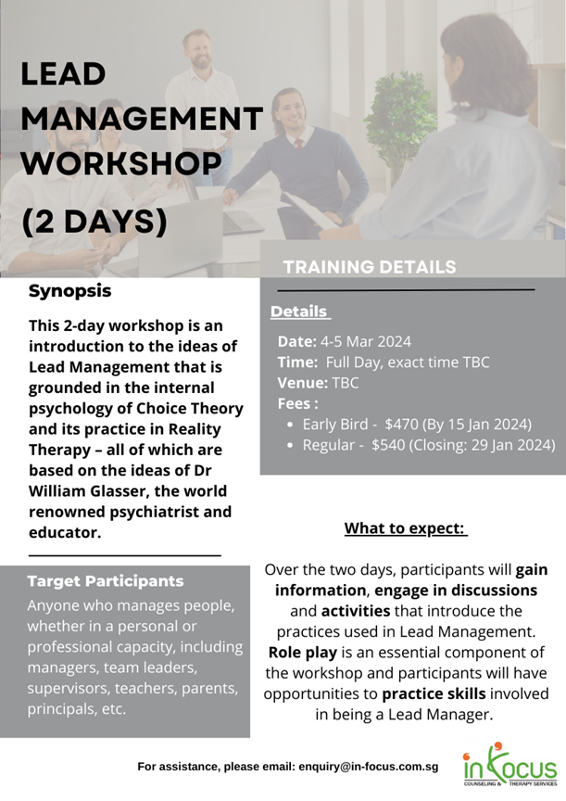

lead management workshop (2 Full Days) on 4-Mar-24 and 5-Mar-24 (Time TBC)
Full Name: Click or tap here to enter text. |  | Mailing Address: Click or tap here to enter text.
Organisation: Click or tap here to enter text. |  | Occupation: Click or tap here to enter text.
Mobile Phone:Click or tap here to enter text. |  | Email: Click or tap here to enter text.
Fees Type (Please indicate 1)
For assistance, please email: enquiry@in-focus.com.sg

☐ | Early Bird Rate $470 | Closing Date: 15-Jan-24
☐ | Regular Fees $540 | Closing Date: 29-Jan-24
Registration is on a first come first serve basis. Registration will be closed once maximum capacity reached.
Payment Method (Please Indicate 1) Note that registration can only be confirmed upon receipt of payment

☐ | Cheque  Payable to In Focus Counseling & Therapy Services. Mail completed registration form and cheque to In Focus Counseling & Therapy Services, No. 150 Orchard Road #08-06 SINGAPORE 238841
 | Amount: Click or tap here to enter text. | Cheque No. Click or tap here to enter text. | Date of Cheque: Click or tap to enter a date.
☐ | Paynow UEN No. 53035317B  Indicate your name under reference during payment and email your completed registration form together with the above details to enquiry@in-focus.com.sg
 | Amount: Click or tap here to enter text. | Date of Payment Click or tap to enter a date.
☐ | Bank Transfer to In Focus Counseling & Therapy Services  Bank Details: UOB Novena Square Branch Code No. 016. Bank A/C No: 339 305 0304  Indicate your name when making the bank transfer for us to trace the payment
 | Amount: Click or tap here to enter text. | Date of Transfer: Click or tap to enter a date.
☐ | Invoice / E-Invoice | Organisation Name : Click or tap here to enter text.
 | Amount:Click or tap here to enter text. | Address:Click or tap here to enter text.
 | Email:Click or tap here to enter text. | Attention to: Click or tap here to enter text.

Cancellation/Withdrawal/Amendment policy: No refunds will be made for withdrawals after the closing date. There will be 50% refund for withdrawals made provided that In Focus Counseling & Therapy Services, being the organiser, receives written notice before closing date. The organiser(s) reserve the right to make changes, divide class, refuse entry or cancel the workshop as a result of unforeseen circumstances.
Data Protection Notice: The personal data provided above is collected and used for the purpose of training registration, administration and to keep participants updated of training and related events and share information on mental and emotional health. Personal data may be disclosed to unaffiliated third parties including our service providers, partners and agents, locally or overseas, for the purpose of providing the services requested by you and related training administration matters; or to relevant authorities for compliance with applicable laws. Upon request, you may access, correct or withdraw consent with reasonable notice. Withdrawal of consent may limit our ability to provide our services to you and does not limit our obligations where disclosure without consent is permissible under applicable laws and the Personal Data Protection Act. If you are submitting the registration on someone else’s behalf, you hereby declare that you have obtained consent from the named individual in this application, for the collection, use and disclosure of his/her personal data for the above stated purposes.

I understand and consent to the above.

Signature : ___________________________ Date: Click or tap to enter a date.

